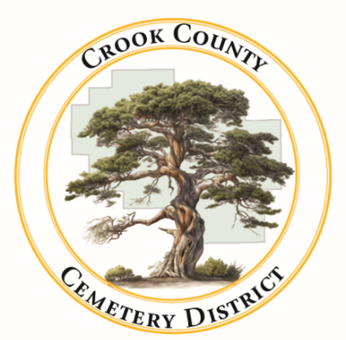 | Crook County Cemetery Improvement District  - February 16th, 2026 Board Meeting  1555 N. Main Street, Prineville Oregon
Date: April, 13 2026 Time: 1:00pm

In Attendance
Susan Hermreck | Gary Bedotha | Craig Yustat | Annalisa Peer
Director | Secretary | General Manager | Administrative Assistant
Item
- Meeting was called to order  The board meeting of the Crook County Cemetery District was called to order with quorum present. |  |  |  |  | Gary Bedortha called meeting to order
- Approval of the meeting minutes from March 16, 2026 |  |  |  |  | Approval was tabled until next board meeting
- Approval of the bills |  |  |  |  | Hermreck made a motion to approve the bills  Hermreck-Yes  Bedortha-Yes  Motion passed
- Reports
- Financial- Report received, discussion tabled

- Operations- Presented by Craig Yustat
The arborist finished up work at Juniper Haven, sprinkler maintenance is on going and a new columbarium is set to be purchased for Juniper Haven.

Old Business

- Continuing Juniper Haven Boundaries Discussion
Further discussion will be tabled until the next board meeting once Yustat and Bedortha meet with the property owner of the mill and review easements with them.
- Addressing Past Due Accounts
The board was presented with a list of past due accounts dating back to 2021. The board asked that all future invoices be mailed with return receipts to ensure they customer was delivered to the correct address. Past due invoices for plots will be reviewed at the next meeting to consider further action to recoup lost funds.
- Projects/ Changes for the New Year
- Sprinklers
Yustat is working on fixing sprinkler issues that arose last summer. Temporary help was not hired.
- Powell Butte Extension
The Powell Butte Cemetery was surveyed and a temporary fence put in place to mark the cemetery boundary. A proper fence will be installed in the coming months. Water rights are being checked with CIOD to cover expanded area.
New Business
2026-2027 Budget Meeting Dates
Discussion was tabled until next meeting.
Public Comments
A public comment from a property owner close to the Powell Butte Cemetery was made concerning the upkeep of the cemetery. The board discussed making a policy to have set dates where old decorations are removed from markers. Discussion will continue at the nest meeting.
Board Member Comments
Meeting Adjourned at 2:20pm

