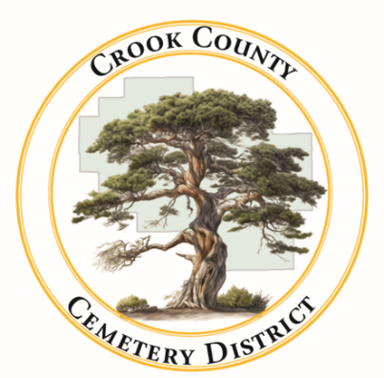 | Crook County Cemetery Improvement District  - February 16th, 2026 Board Meeting  1555 N. Main Street, Prineville Oregon
Date: April, 30 2026 Time: 2:00pm

In Attendance
Susan Hermreck | Sherra Moore | Craig Yustat | Annalisa Peer | Jamie Wood
Director | Accountant | General Manager | Administrative Assistant | Board Chair
Steve Shropshire
Legal Representation
Item
- Meeting was called to order  The budget meeting of the Crook County Cemetery District was called to order with quorum present. |  |  |  |  | Jamie Wood called meeting to order
- Review Legislative & Financial Forecast Updates
The board discussed increasing the fuel budget to accommodate a gas tax if passed and current price increases for fuel.
- Strategic Plan Budget
The board addressed each line item in the budget report. Amendments to the budget will be made at the next board meeting.
- Review Budget Development
The board discussed future projects with each cemetery and proposed a budget to accommodate those projects.

Board President’s General Recommendations and Committee Discussion
- Next Meeting Dates
The next budget meeting date was set for May 15th at 1:00pm at the Crook County Library
Meeting Adjourned at 3:40pm

