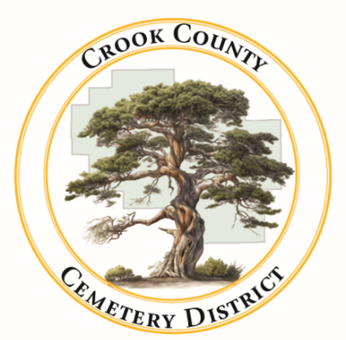 | Crook County Cemetery Improvement District  - November 10th 2025 Board Meeting  1555 N. Main Street, Prineville Oregon
Date: November 10, 2025 Time: 1:00p.m.

In Attendance
Jamie Wood | Annalisa Peer | Gary Bedortha | Susan Hermreck | Craig Yustat
Board Chair | Administrative Assistant | Secretary | Director | District Manager
Sherra Moore | Steven Shropshire
Accountant | Legal Team
Item
Meeting was called to order  The board meeting of the Crook County Cemetery District is called to order with quorum present. |  |  |  |  | Jamie Wood called meeting to order
- Consent Agenda
- Meeting minutes from October were approved
- Reports  - Financial – Presented by Sherra Moore  Sherra provided a financial update: financially everything looks good and health insurance renewal time is here  - Operations ~ Presented by Craig Yustat  Craig provided an update on the cemetery operations: on going equipment issues, mowing season has ended, and an arborist will be finishing some tree work around a few of the cemetery locations |  |  |  |  | Motion made by Jamie Wood to approve the bills  Motion passed  Board approved the Bills

Old Business
- Bylaws development
Members agree to table this discussion until further progress is made by the legal team

New Business
- Budget Amendments for Staffing
Board discussed need to adjust budget for additional full-time position. Budget will be reviewed to make appropriate changes.
- Benefits for Staff members
Board is looking into switching health insurance providers to help offset some of the new staffing cost with a reduction in health insurance costs. Discussion is postponed until next meeting when health insurance costs are known.
Craig will look into insurance options and figure out their cost.
- Holiday Hours
Board discussed holiday hours and gifts for staff. Proposed holiday hours were approved as well as staff gifts. Holiday hours will be posted on the website.
- Cemetery Expansion Possibilities
The land around the cemetery that was owned by the mill is going to be up for sale soon. The board started the conversation about potentially purchasing some of the land to use as an expansion someday down the road. The board noted that this might be the only chance the cemetery will get to expand.
- Headstone Sales
Discussion about making adjustments to the way the cemetery sells headstones. Annalisa agreed to start taking a deposit on headstones and Sherra will work on making a line item for headstones in the financial report.
Adjournment at 1: 50 pm

