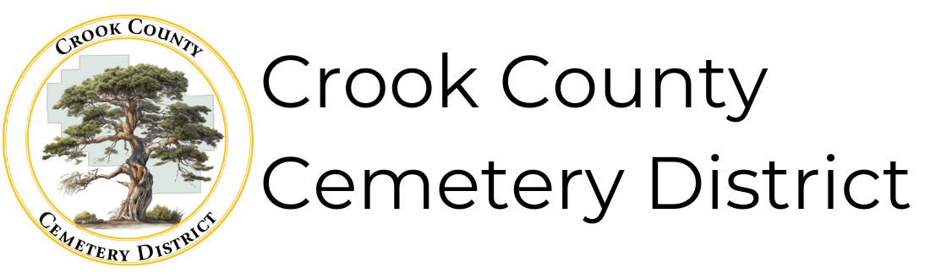
Crook County Cemetery District
1555 N. Main St.
Prineville, OR 97754
(541) 447-4611
Cemeterydistrictpubliccomment@gmail.com
Board of Directors Meeting
March 16. 2026 1:00 p.m.
The Board of directors will meet in person at 1:00 p.m. at the Crook County Library Juniper Room-175 NW Meadow Lakes Dr. Prineville, OR 97754, with a virtual meeting option available by Zoom. The public may provide input in-person at the meeting or via the virtual Zoom link.
Join Zoom Meeting
https://zoom.us/j/99842753686?pwd=en6kERgNJ0dHCPDIAiSkeyJ8aUazbb.1
Meeting ID: 998 4275 3686
Passcode: 397076
AGENDA
- Call to order
- Approval of meeting minutes from February 16, 2026
- Approval of the bills
- Reports
  - Financial
  - Operations
- Old Business
  - Adopting 26-001: adopting policies directing the compilation of the board policy book
  - Continuing Juniper Haven Boundaries Discussion
  - Projects/ Changes for the New Year
    - Fees Discussion
    - Fencing Beaver Creek
    - Sprinklers/ Paving Juniper Haven
    - Powell Butte Extension
- New Business
- Public comments – (limited to 3 minutes each)
- Board member comments
- Adjournment

The meeting location is accessible to persons with disabilities. A request for an interpreter for the hearing impaired or for other accommodations for persons with disabilities should be made at least 48 hours before the meeting to Craig Yustat (541) 447-4611.

