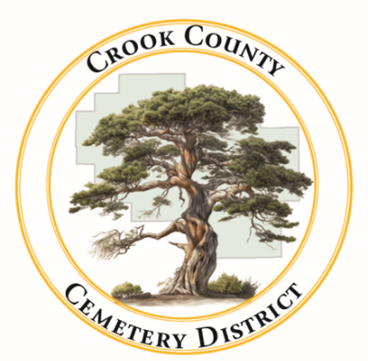 | Crook County Cemetery Improvement District  - December 22, 2025 Board Meeting  1555 N. Main Street, Prineville Oregon
Date: December 22, 2025 Time: 12:30pm

In Attendance
Jamie Wood | Annalisa Peer | Gary Bedortha | Susan Hermreck | Craig Yustat
Board Chair | Administrative Assistant | Secretary | Director | District Manager
Sherra Moore | Steven Shropshire
Accountant | Legal Team
Item
Meeting was called to order  - The board meeting of the Crook County Cemetery District is called to order with quorum present. |  |  |  |  | Jamie Wood called meeting to order
- Consent Agenda  - Meeting minutes from November were approved |  |  |  |  | Jamie Wood made a motion to approve November meeting minutes  Motion passed
- Approval of the bills  - Bills were approved for the month |  |  |  |  | Motion made by Jamie Wood to approve the bills  Motion passed  Board approved the Bills
- Reports
  - Financial – Presented by Sherra Moore
Tax money is coming in. We are now tracking marker sales separately from other income.

  - Operations ~ Presented by Craig Yustat
Discussed option to fix irrigation issues by bringing in a professional. Trees are being trimmed and hazard trees have been removed. Clearing the curbs is still ongoing. Work on the expansion at Powell Butte/ Pilgrims Rest Cemetery.

Old Business
- Mill closing/reopening next door
Gary Bedortha looked at the historic easements between the mill, the cemetery, and the recycling facility. Past board meeting minutes were checked to analyze the cemetery’s property lines and determine what the next steps should be for acquiring more land for future cemetery development.
The board agreed to use part of the January board meeting to conduct a site visit to help determine next steps.
- Continuing Budget Amendments Discussion from November
The board asked that Prineville Insurance give a presentation to the board at the next meeting.
Health insurance policies are still being reviewed.
- Bylaws development
The board will be receiving a copy of the draft bylaws created by legal council after the meeting. The board will review the bylaws for the next board meeting.
New Business
- Damaged Monument  Craig Yustat gave a recount of the issues with a headstone at the Juniper Haven Cemetery. A headstone had fallen over and was resecured by the cemetery staff and an employee at Jessies Monuments. The owner of the headstone requested that the cemetery replace the headstone. The problem was taken to the board to make a call on how to procced. The board agreed that this was a special case due to past issues with the headstone created by past management. The board along with help from legal council agreed that the cemetery will fix the scratch in the headstone but would not be replacing the stone.  The board told the cemetery employees to include a signature for all future plot sales that acknowledges the plot owner received a copy of the cemetery rules and regulations. |  |  |  |  | Jamie Wood makes a motion that under the special cases amendment in the cemetery rules and regulations the board will offer to fix the scratch in the headstone after finding three different companies to give prices for fixing the headstone. The bids will be brought to the next meeting. The motion also includes allowing Susan Hermerick to contact the individual with the headstone and inform them of the outcome of this meetings discussion.  Motion Passes
- Benefits for Staff members
Board is looking into switching health insurance providers to help offset some of the new staffing cost with a reduction in health insurance costs. Discussion is postponed until next meeting when health insurance costs are known.
Craig will look into insurance options and figure out their cost.
- Holiday Hours
Board discussed holiday hours and gifts for staff. Proposed holiday hours were approved as well as staff gifts. Holiday hours will be posted on the website.
- Cemetery Expansion Possibilities
The land around the cemetery that was owned by the mill is going to be up for sale soon. The board started the conversation about potentially purchasing some of the land to use as an expansion someday down the road. The board noted that this might be the only chance the cemetery will get to expand.
- Headstone Sales
Discussion about making adjustments to the way the cemetery sells headstones. Annalisa agreed to start taking a deposit on headstones and Sherra will work on making a line item for headstones in the financial report.
Adjournment at 1: 50 pm

